Digital Logic & Design Lab

Experiment No. 9

Slot: L55 + L56

Done by: A. Sai Nikhil

Reg No: 15BCE0264

Question no.1: Truth table and software implementation of all available flip flop.

1. R-S Flip Flop

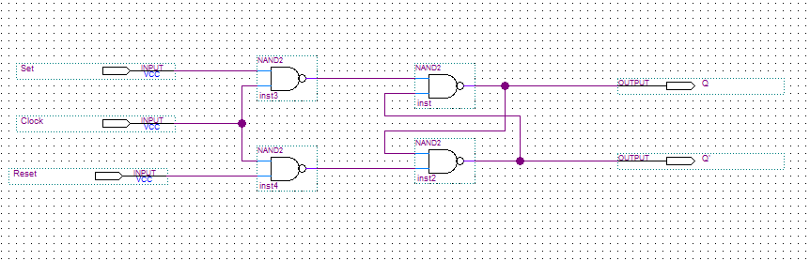

|  |  |  |  |
| --- | --- | --- | --- |
| Q | Set | Reset | Q(t+1) |
| 0 | 0 | 0 | 0 |
| 0 | 0 | 1 | 0 |
| 0 | 1 | 0 | 1 |
| 0 | 1 | 1 | Indeterminate |
| 1 | 0 | 0 | 1 |
| 1 | 0 | 1 | 0 |
| 1 | 1 | 0 | 1 |
| 1 | 1 | 1 | Indeterminate |

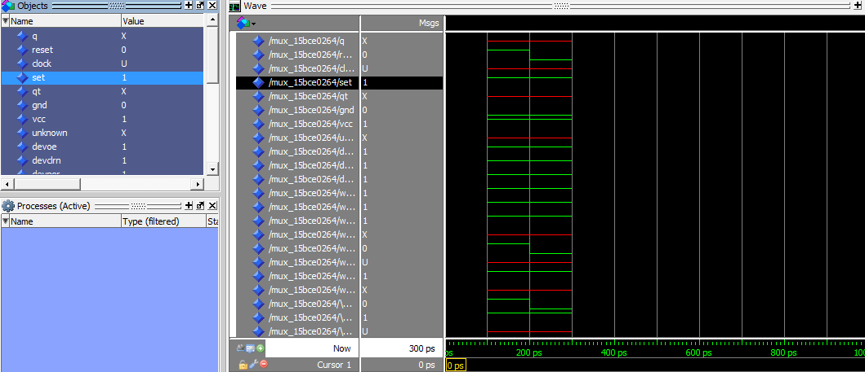

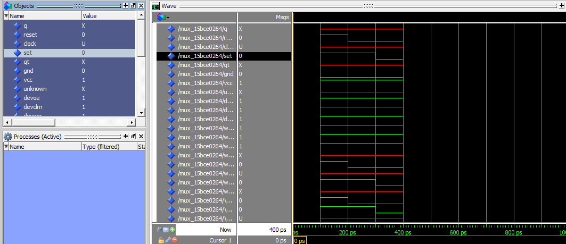

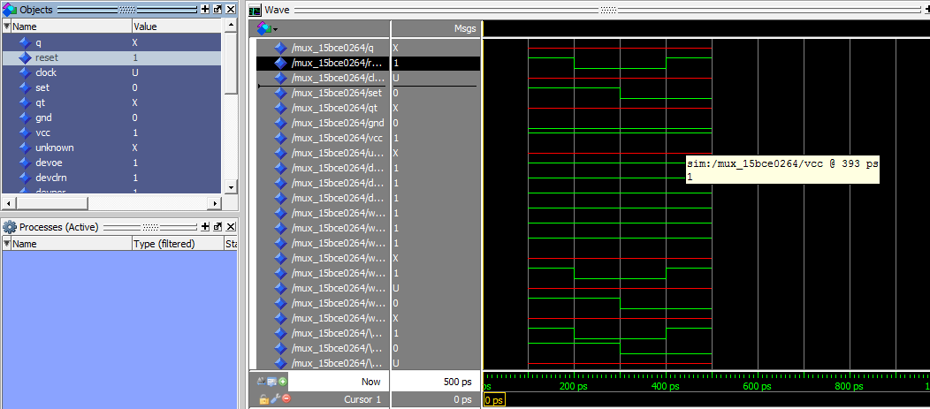

1. D – Flip Flop

|  |  |  |
| --- | --- | --- |
| Q | D | Q(t+1) |
| 0 | 0 | 0 |
| 0 | 1 | 1 |
| 1 | 0 | 0 |
| 1 | 1 | 1 |

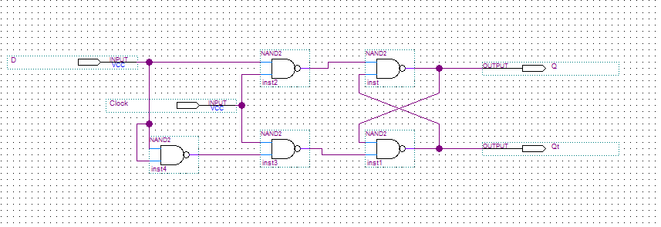

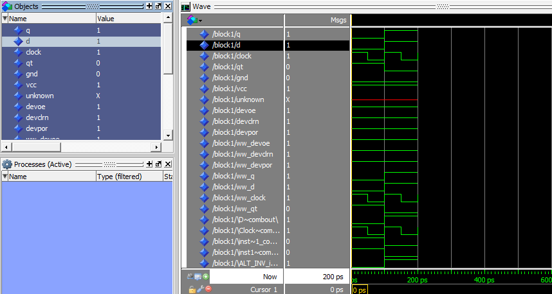

1. J-K Flip Flop

|  |  |  |  |
| --- | --- | --- | --- |
| Q | J | K | Q(t+1) |
| 0 | 0 | 0 | 0 |
| 0 | 0 | 1 | 0 |
| 0 | 1 | 0 | 1 |
| 0 | 1 | 1 | 1 |
| 1 | 0 | 0 | 1 |
| 1 | 0 | 1 | 0 |
| 1 | 1 | 0 | 1 |
| 1 | 1 | 1 | 0 |

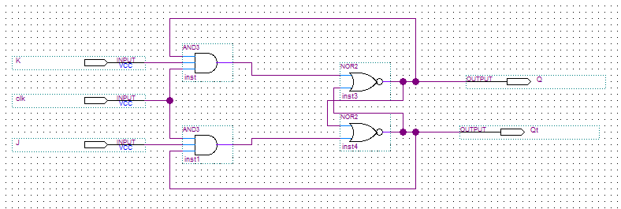

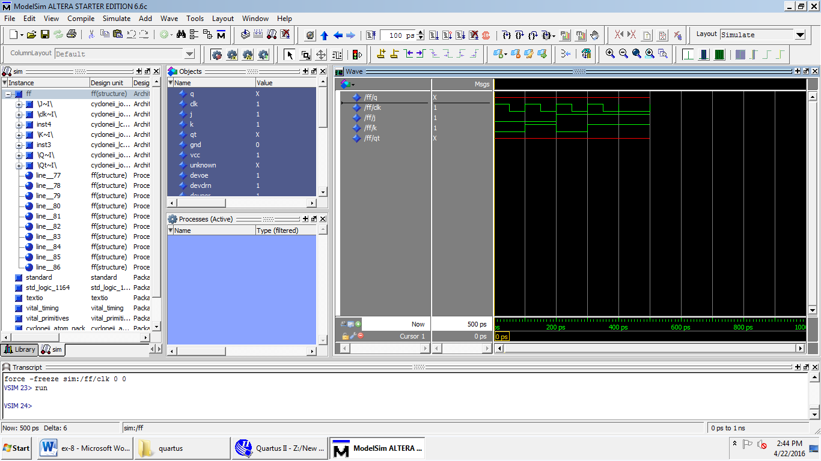

1. T- Flip Flop

|  |  |  |
| --- | --- | --- |
| **Q** | **T** | **Q(t+1)** |
| **0** | **0** | **0** |
| **0** | **1** | **1** |
| **1** | **0** | **1** |
| **1** | **1** | **0** |

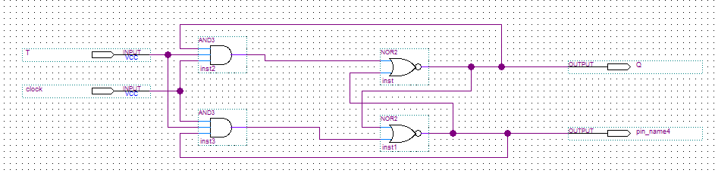

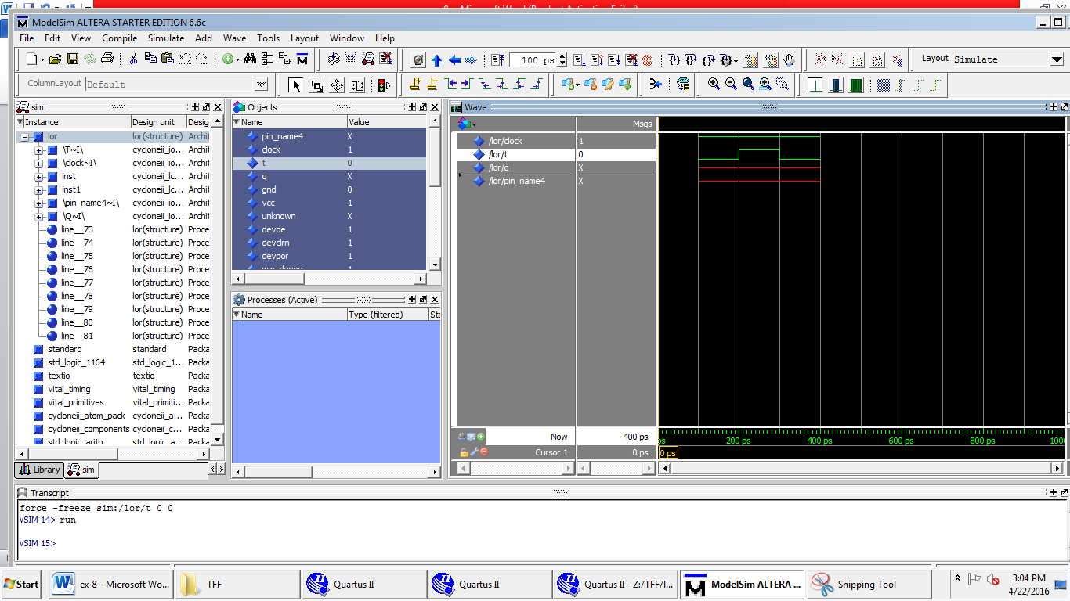

Question no. 2: Construct the sequential network and determine the state table, also draw the state diagram.

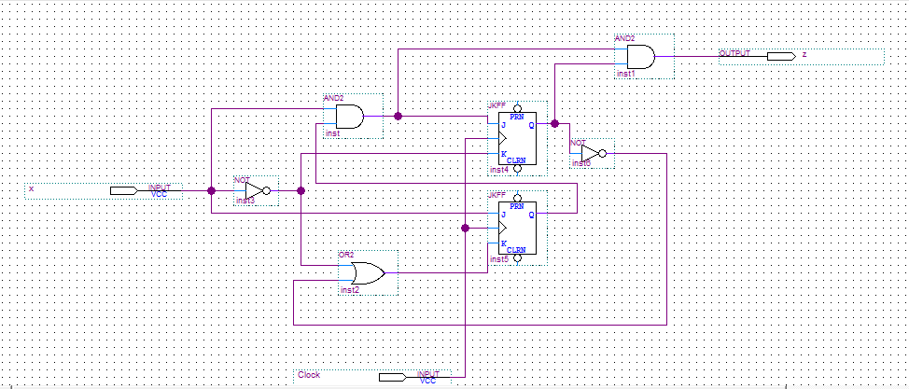

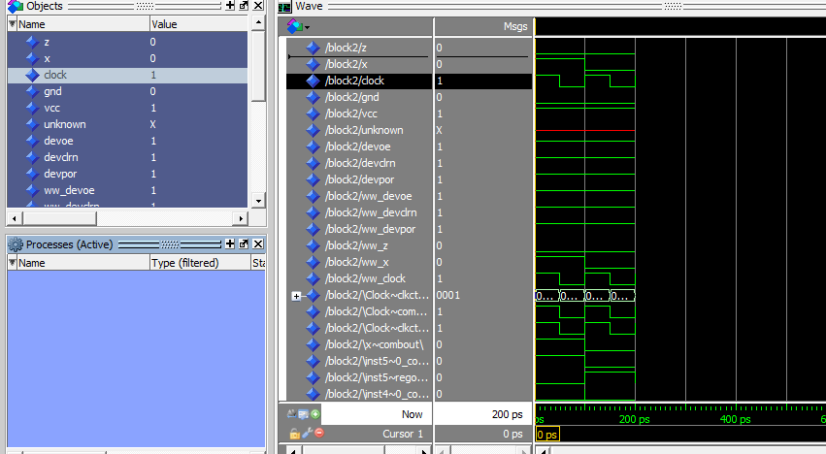

|  |  |  |  |  |  |  |  |
| --- | --- | --- | --- | --- | --- | --- | --- |
|  |  | x=0 | x=0 | x=1 | x=1 | x=0 | x=1 |
| A | B | A | B | A | B | z | z |
| 0 | 0 |  |  |  |  |  |  |
| 0 | 1 |  |  |  |  |  |  |
| 1 | 0 |  |  |  |  |  |  |
| 1 | 1 |  |  |  |  |  |  |

Question no. 3: